**8/22/2022**

Proposal for   
**Book Review Platform Development**

Project name: BookRevBD (BR)*

Submitted by:

|  |  |
| --- | --- |
| **Name** | **ID** |
| Nawal Ayesha Khan | 1911301042 |

North South University, Bashundhara, Dhaka, Bangladesh

**Email**: nawal.khan@northsouth.edu  
**Phone**: +88 028411111  
**Website**: https://bookrevbd.000webhostapp.com/

* Name can be changed

# Table of Contents

Table of Contents 2

Tables 3

Introduction 4

About Group-9 Limited 4

Background and Product Context 5

User Story 6

Use Case 1: 6

Use Case 2: 6

Use Case 3: 6

Use Case 4: 6

Use Case 5: 7

Limits 7

Solution Description 8

Architecture 8

Front-end plan 9

Back end development 10

Performance plan: 11

Google Page evaluation (https://developers.google.com/speed/pagespeed/insights/) 11

Others Comments 11

Development Plan 11

Phase 1 11

Deliverables: 11

Phase 2 11

Deliverables: 11

Phase N 12

Hardware/Hosting Plan 13

Project Schedule 14

Appendix 15

Contact information 15

# Tables

Table 1: Cloud hosting plans 13

Table 2: Phase 1 and 2 Schedule 14

# Introduction

This is a proposal for the development of a book review website where users can write reviews for books. In this system users can search for books and provide feedback for them. Users will be able to know the latest books of their interests being introduced into the market like fiction, science, technology etc. This document contains high requirements, user stories, phase-wise development outline and expectations. It will remain as a document to be shared online collaboration to undergo phase wise changes as the product matures into a proper platform.

## About Group-9

The group consists of 1 member: Nawal Ayesha Khan (1911301042).

Learn more at <https://bookrevbd.000webhostapp.com/>.

# Background and Product Context

Book lovers read a lot of books, and buy new books frequently. A book review website helps them to know about books before purchasing them. It lets them know if a certain book meets their requirements or not. Not only will the reviews give them an idea of the story, genre and tone of the book, they also get a valuable impression of its quality. Book reviews give books greater visibility and a greater chance of getting found by more readers. On some websites, books that have more book reviews are more likely to be shown to prospective readers and buyers as compared to books with few or no book reviews. Reader reviews tend to be more personal, focusing on the individual reader’s experience while reading the book. But since readers can have such widely differing views of the same book, it is valuable for all involved when a book has a variety of reader reviews available. The benefits of book review are immense. In fact, book reviews help potential readers become familiar with what a book is about, give them an idea of how they themselves might react to it and determine whether this particular book will be the right book for them right now.

Reviews also make it easier to find an author's book. Reviews can help move an author’s book up the search ranking on sites like Amazon or Goodreads, and reviews can also help their SEO (search engine optimization). Reviewers will use keywords like the title of a book, author’s name, the genre and sub-genres of the book. The more times these things are mentioned, the better the chance of a book getting pulled up in searches results for those words. Increasing the traffic to your book pages combine with good reviews of your book are the best ways to lead to the sale of your book. They also inspire confidence in the rising authors. Seeing good reviews on their own writing skills will motivate him to write and publish more amazing books to the market. A detailed review can save readers time, prepare them for what they will find, and offer them a greater chance of connecting with a particular book, even before they read the first page. They give books greater visibility and a greater chance of getting found by more readers. On some websites, books that have more book reviews are more likely to be shown to prospective readers and buyers as compared to books with few or no book reviews. Reviews on a site can also help amplify one's book’s reach among book clubs, bookstores, blogging communities and other opportunities to gain attention from new readers. Books with a lot of book reviews will appear to be more in-demand. It is human nature for people to be curious about what seems popular and check it out for themselves. As a result, a good number of book reviews can help lead to a snowball effect in book sales.

The reviews are also effective on the buy-and-sale market. Customers are particularly unsure of products with no consumer reviews, including books. Stores like Kindle are full of books, and some are of much better quality than others. Regular shoppers are likely to have spent money on a poorly written book before and are now more cautious about buying. But if a book has several good reviews, the buyer’s faith in that product is higher. Reviews work excellently with the algorithms used by online stores. The more reviews an author gets, the more shoppers are shown his book. The more shoppers see his book, the more sales you’re going to make. If you can legitimately tap into this, you have a fantastic marketing opportunity. In other words, the presence of book reviews can help validate the worthiness of a book and establish who the book’s audience is. Then once validated, other similar people are much more likely to want to join their peers and buy that same book. Book ratings also work in building brands. Building your brand as an author helps target the specific audience reading your genre. Book reviewers are able to build your brand like no one else. The more reviews that say things that build and boost your brand, the more people will have trust in your ability to craft a compelling story. Reviewers can let people know what genre you write in and if you excel in that genre. Being known as a writer who is great at world-building, especially for sci-fi or fantasy, will help target readers who look for that in the books they choose.

Many also want to keep track of books they enjoy, books they are yet to read, etc. and digital collections of books have become a very convenient way of doing this. Following others on social media to know of their opinions is a very common practice, and having such a feature in book review sites to stay informed on what literature your peers are interested in currently and whether they fit into your preferences would be a valuable addition. Considering the above benefits of such review sites, there is room to create a website providing book reviews that also acts as a way for book-lovers to stay connected. Reviewing books, following and reading others’ reviews, saving books according to your taste, and other such features are a valuable way for avid book readers to share their opinions on their favorite pieces of literature.

In this system, users can search for books by title, genre, or author. Users can review a book by giving it a title and providing some additional feedback. Users are able to create collections/libraries and add and remove books to and from them. Users can view a book’s information and its reviews. Users will be suggested users based on the books they review. Users are also able to follow other book reviewers and see what books are being reviewed well. Admin users will be able to edit or remove any inappropriate reviews. Admins can view and add User information; add and remove review and library information.

# User Story

## Use Case 1:

## Ms. Nabila (A user on the site) wants to search for books according to her preferences. There are 3 ways to do this:

## She uses the search bar in the website to search for books by author or title. She can then click on these books to see their details like Title, Author(s), Description, Year published, etc.

## She clicks on the option in the dashboard to see books of a certain genre. Based on the option, she will be able to view different books and see their details.

## She goes to her home page and sees which books the users she follows have reviewed, and clicks on the reviews to see if the books match her preferences.

**Use Case 2:**

Ms. Nabila (A user on the site) wants to review books she has recently read and share her opinions on them. She can do this by:

1. Searching for books by title, clicking on the button to review them and leaving a concise review.

## Use Case 3:

Ms. Nabila (A user on the site) wants to keep track of books she has completed or will read soon in her personal libraries. There are 3 options to do this:

a) She searches for books by title or author, or chooses option to see books of a certain genre in her dashboard, and clicks on the button next to them to save them to different libraries.

b) She views which books her fellow users have reviewed and clicks on the button next to them to add them to her libraries.

c) She can select the books she has already reviewed and save them to libraries by clicking on the button next to them.

**Use Case 4:**

Mrs. Nabila (Administrator on the website) wants to add reviews in the website. She can do this by:

1. Clicking on the add button in the Review panel to a create review for a random book.
2. Searching for a book and clicking on the Add Review button next to it to create a review for the book.

## Use Case 5:

Mrs. Nabila (Administrator on the website) wants to remove or edit reviews that are controversial or redundant so that the website is cleaner. She can do this by:

1. Clicking on the edit or delete button to change or remove a review.

## Limits

1. Book information is limited to what is provided by Google Books, and cannot be modified.
2. Books cannot be added to multiple libraries simultaneously.

# Solution Description

## Architecture

Architecture plan for the website flow has been displayed below:

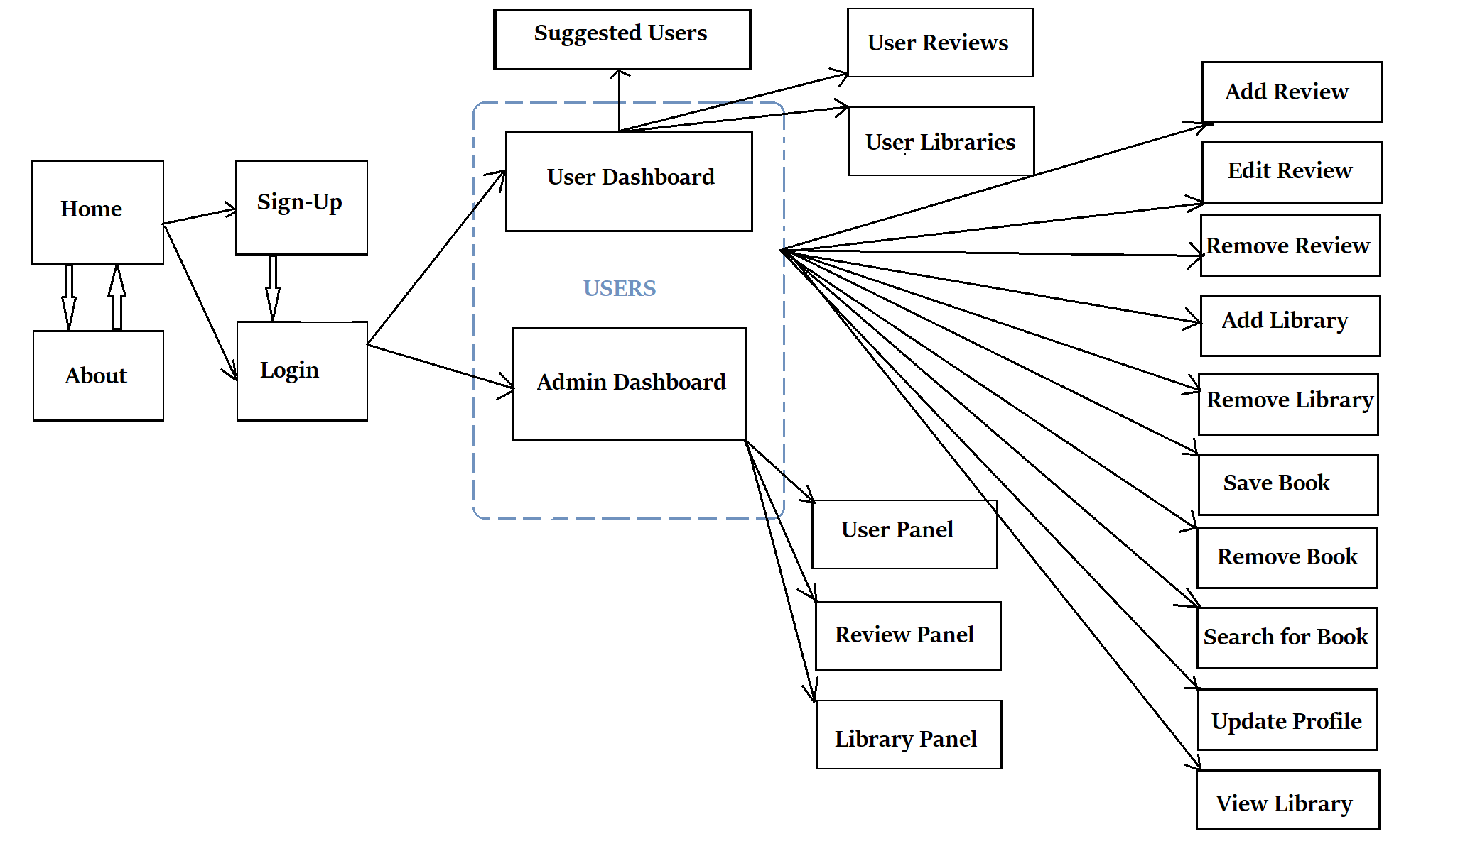

Figure 1: Architecture Plan

Central MySQL DB will receive requests from clients in the form of browsers, which will then respond to the server’s requests with the necessary information and media. 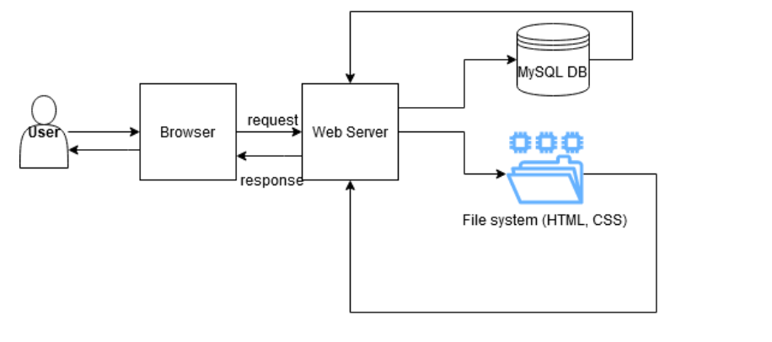

Figure 2: High-level architecture plan

The first phases focused on basic and initial UI and meeting acceptable performance benchmarks as set by Google and open source benchmarking tools available in the industry. The website used a MySQL DB for the information for User, Review, Library, Following, and Library_Shelf.

To facilitate rapid development, the PHP scripting language will be used for server side programming. Since PHP provides flexibility, performs efficiently, and is easily integrated, it will accelerate quick development into a fully maintainable website. HTML, CSS, and Bootstrap will be used to design the front-end.

## Front-end plan

Initial plans for the front-end development are detailed below.

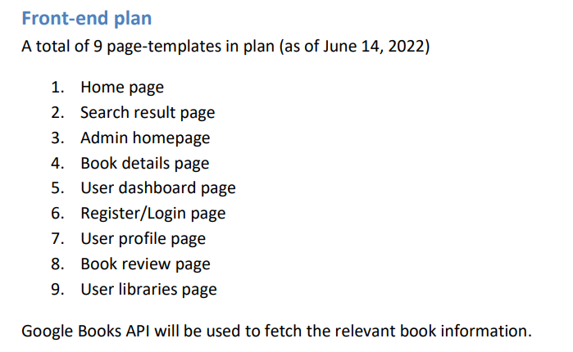

Figure 3: Snapshot of initial Front-end plans

A total of 24 page-templates were designed (as of August 22nd, 2022):

1. Home page
2. Register/Login page
3. About page
4. Admin dashboard
5. Admin User Panel
6. Admin Review Panel
7. Admin Library Panel
8. Admin View Library Panel
9. Admin View User Reviews Panel
10. User Dashboard page
11. User Libraries page
12. User View Library page
13. User Reviews page
14. Suggested Users page
15. Book details page
16. Search results page
17. View and Edit Profile page
18. Book Information page
19. Add Review form
20. Edit Review form
21. Add Library form
22. Add Book to Library form
23. Registration form
24. Login form

Google Books API will be used to fetch the relevant book information.

## Back end development

Initial plans for Back-end development are detailed below.

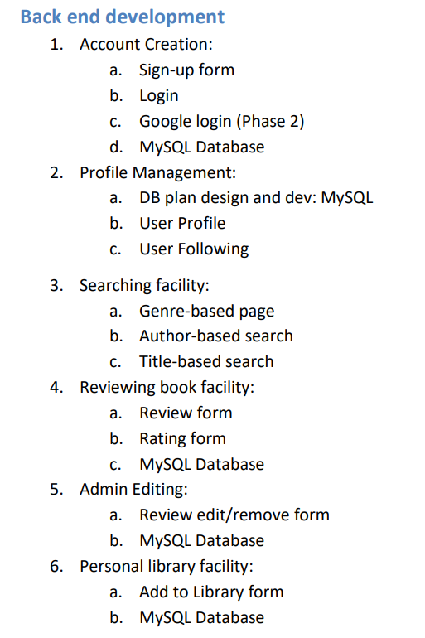

1. Account Creation:

a. Sign-up form

b. Login

c. MySQL Database

1. Profile Management:
   1. DB plan design and dev: MySQL
   2. User Profile
   3. User Following
   4. Edit Profile form
2. Searching facility:
   1. Genre-based page
   2. Author-based/Title-based search
   3. Book details and Reviews
3. Reviewing book facility:
   1. Review form
   2. MySQL Database
4. Admin Management:
   1. Review add/edit/remove panel
   2. Library add/ remove panel
   3. User add/view review panel
   4. MySQL Database
5. Personal library facility:
   1. Create Library form
   2. Remove Library form
   3. Add to Library Form
   4. Remove from Library form
   5. MySQL Database

## Performance plan:

### Google Page evaluation (https://developers.google.com/speed/pagespeed/insights/)

* Mobile 92/100 (bdjobs.com at 74/10)
* Desktop 99/100 (bikroy.com at 85/100)

## Others Comments

* Web-based application
* Separate panels for Admin and Regular Users
* Responsive Front end
* CDNs used to fetch icons for website
* Users can not spam reviews for a book.

# Development Plan

Development methodology adopted agile methodology. Each cycle was completed in exactly 2 weeks (10 working days). At the end of each cycle, the developing team released a working software version.

## Phase 1

Duration: Total 6 weeks for development and 1 week for final deployment. This phase shall develop a minimum viable product (MVP) with basic and initial UX.

Phase 1 focused on implementing Account creation, as well as Admin and User actions, and allowing users to follow each other.

### Deliverables:

At the end of this phase, users were able to register/login to their account. Users can follow other users and view their reviews. Admins can add, edit or remove reviews from the website. Website should also be fully responsive for all users.

## Phase 2

It focused on Profile management for the Users. It also focused on developing the Searching, Book reviewing, and Personal Library collection facilities through API integration. It satisfies use cases as described in the use case section update as of 23rd August, 2022.

### Deliverables:

At the end of this phase, Users were able to view and edit their profiles, such as name and password. Users can search for books and leave reviews for them, as well as click on the books to see any related information. Users will be able to find a review of the book they’re interested in quickly. Searching facility will help the users to find something new to read. An API will be used to fetch relevant book details. Users can also save books to their personal libraries.

## Phase N

Phase 1 and Phase 2 will help decide goals and expectation for the next phase. The   
evolved user stories and learning from utilization gathered from different users all   
together will help guide design and development. Hence prior to this next phase it will be   
important to have a solid planning session.

# Hardware/Hosting Plan

Here is a list of hosting plans. We chose one that best fits our website, along with being the most economical.

Table 1: Cloud hosting plans

|  |  |  |  |  |  |  |  |
| --- | --- | --- | --- | --- | --- | --- | --- |
| **Cloud Provider** | **DC location** | **Latency (ms)** | **Starter description** | **Starter price**  **(USD)** | **Mobile app ext. (with Redis)** | **Mobile app ext. price (USD)** | **Total expense (USD/mo)** |
| 000webhost (Hostinger International Inc.) | Lithuania | 170 | Transfer 300 MB, 0.07 $/GB | $0.00 | 300 MB disk | $1.99 | $0.00 |

# Project Schedule

Phase 1 and 2 took a total of 6 weeks from the starting day. Calculated Man-month = 8.5/4 = 2.123. Excluding front end development it becomes:

Table 2: Phase 1 Schedule

|  |  |  |  |  |  |  |  |  |  |  |  |  |
| --- | --- | --- | --- | --- | --- | --- | --- | --- | --- | --- | --- | --- |
|  |  | **Week** | | | | | | | | | |  |
| **SL** | **Deliverable** | **1** | | **2** | | **3** | | **4** | | **5** | | **Man-week** |
| 1 | Front end development* | - | - | - | - | - |  |  |  |  |  | 2.5 |
| 2 | Account management |  | - | - | - |  |  |  |  |  |  | 1.5 |
| 3 | Profile management |  |  |  | - | - | - |  |  |  |  | 1.5 |
| 4 | Search, Reviewing, and Library facilities |  |  |  |  | - | - | - | - |  |  | 2.0 |
| 5 | Deployment and final release |  |  |  |  |  |  |  | - | - |  | 1.0 |
|  | **Total duration** | **1.5** | | **2.5** | | **2.5** | | **1.5** | | **0.5** | | **8.5** |

* Front end to HTML conversion was done by the Group-9 team

# Appendix

## Contact information

Contact Person Name: Nawal Ayesha Khan

Email: nawal.khan@northsouth.edu

Mobile: +8801817181156

**North South University, Bashundhara, Dhaka, Bangladesh**

**Email: nawal.khan@northsouth.edu**

**Web :** [**https://bookrevbd.000webhostapp.com/**](https://bookrevbd.000webhostapp.com/)

**Instructions:**

1.Pull from the linked Github repository into the ‘htdocs’ folder inside your ‘xampp’ directory.

2. Run the Apache and MySQL servers on Xampp Control Panel.

3. Type ‘http://localhost/book_review/index.php’ into the search bar of your browser to access the homepage of the site.